HW 7 – CIS 4374
Research:
What does already exist?
I found parking platforms that are popular in the market like ParkMobile, SpotHero, Parksy, and PayByPhone.
Add existing software landscape to your document
After doing my research on these five popular parking platforms, they have their own parking app for both App Store and Google Play. They also have a ton of features that set each other apart such as real-time availability, pre-booking, long-term parking, and easy payment options. One con about all the parking platforms is that they are limited to only big cities.
How will your application be different from what already exists?
My application will be different from what already exists by adding in all the features that exist including AI assisted chat, big cities, and little cities parking, website for the instructions meaning step by step guide on how to use the application, support, easy accessibility and usage, gps navigation with Apple Maps or Google Maps on the platform, simple payment methods, book a parking reservation ahead of time for future events and scout for the cheapest parking in the location near the area.
Vision and Scope
How was this project acquired, introduction of my fictional company and a rough overview of what this project is about?
The project was introduced and acquired when I was trying to find parking for my date, and I was struggling to find parking that was nearby and close to the date spot. I tried all these parking apps, and they found me at parking spots that were 20 minutes walking distance away from the date spot. I was frustrated with having to walk a mile to get to my spot, so I developed a smart parking spot application that allows everyone to find good parking and have the functionality and usage like all the other apps. The overview of this project is to help drivers find parking easier by implementing an application that allows drivers to find out and show parking spaces. This also helps parking operators to decide what rates to charge, check parking efficiently, and improve the parking situation for drivers. That is why I introduced a company to the name of $oftware Corp to help drivers get out frustrating situations over parking.

Draft for SRS
- Software Requirements Specification (SRS)
- Project Name: Smart Parking Platform
- Version: 3.4
- Date: 10.28.2026

1.Introduction
- 1.1 Purpose
  - This document defines the requirements for Smart Parking Platform project.
- 1.2 Scope
  - Our mission at $oftwareCorp is to reduce the amount of time drivers have to spend looking for available parking. $oftwareCorp will provide the parking operators with better and improved technology to monitor latency, pricing, and operations.
2. Overall Description
- - Users: People above 18 that can drive, the age demographic where people can drive
- - System environment: Web-based / Mobile application
- - Constraints: Must have a device to use, must require payment method
- - Assumptions: Application has internet access; real-time availability
3. Functional Requirements
- FR1: The system should allow the user to register and log in securely.
- FR2: The system should allow the user to add and choose payment methods.
- FR3: The system should display a search bar to search for addresses.
- FR4: The system should generate and email payment receipts.
4. Non-Functional Requirements
- NFR1: The system should support at least 2,000 active users.
- NFR2: The system should display live parking within 10 minutes.
Use Case
1.
- Title: Add user registration to the web-based / mobile application
- Actor: User
- Precondition: User has on the website or has the app installed, does not have an account
- Steps:
  - 1. User selects “Sign Up” or “Register
  - 2. User fills in personal information
  - 3. User verifies email address
  - 4. User is officially setting up an account.
- Postcondition: users can login
2.
- Title: Add user payment method
- Actor: User
- Precondition: User adds payment method for future uses
- Steps:
  - 1. User selects the payment method (Debit/Credit)
  - 2. User enters their payment information
  - 3. User now has a form of payment.
- Post condition: payment can now be available for use
3.
- Title: Multifactor Authentication
- Actor: User
- Precondition: User adds multifactor authentication to secure login
- Steps:
  - 1. User selects “Login information”
  - 2. User selects “MFA authentication”
  - 3. User setups MFA via email
  - 4. User tests the MFA by logging out and logging in
- Post condition: mfa setup is complete
4.
- Title: Add search bar for parking search
- Actor: User
- Precondition: users use search bars to find parking spots
- Steps:
  - 1. User clicks or taps on the search bar
  - 2. User searches nearest parking spots
  - 3. User finds a parking nearby parking spot
- Postcondition: User has a list of parking spots near the location of address
5.
- Title: Add live update for parking space availability
- Actor: User
- Precondition: user refreshes parking space to see if it becomes available
- Steps:
  - 1. User searches for parking spaces
  - 2. User finds a parking space
  - 3. User views that parking spaces are full
  - 4. User taps the refresh button
  - 5. User finds a parking space
- Post Condition: refresh button gives update to display
6.
- Title: Add interactive map to display parking spots/locations
- Actor: User
- Precondition:
- Steps
  - 1. User arrives at the destination
  - 2. User cannot find parking spot
  - 3. User searches for parking spots nearby
  - 4. User sees parking spots by looking at an interactive map
- Post condition: interactive map can move and display parking spots nearby
7.
- Title: Add apple pay or google pay as a form of payment
- Actor: User
- Precondition: user finds parking spot and pays for parking spot using apple/google pay
- Steps:
  - 1. User finds a parking spot
  - 2. User pays for the parking spot
  - 3. The system gives the user multiple option methods credit or apple pay or google pay
  - 4. User uses google pay or apple pay to pay
- Post condition: apple pay and google pay are available for use
8.
- Title: Add parking reservation
- Actor: User
- Precondition: user purchases parking reservation
- Steps:
  - 1. User wants to book a parking reservation for an event
  - 2. Users find parking space available for an event the next day
  - 3. User books a parking reservation for the event
- Post condition: parking reservation is available for purchase
9.
- Title: Add a calendar for parking reservation
- Actor: User
- Precondition: users book a parking reservation, calendar is installed
- Steps:
  - 1. User wants to book reservation for the day/week/month ahead of time
  - 2. User finds a solid parking space
  - 3. User books the parking reservation
  - 4. User finds the parking spot on the calendar
- Postcondition: calendar is available and shows parking reservation
10.
- Title: Add an email confirmation for booking parking reservation
- Precondition: users book a parking reservation, email confirmation is installed
- Actor: User
- Steps:
  - 1. Users book a parking reservation
  - 2. User pays for a parking reservation
  - 3. User gets email confirmation of the parking reservation
- Post condition: email confirmation is ready for use
11.
- Title: Add reservation history and receipts
- Actor: User
- Precondition: user purchases a parking reservation, reservation history and receipts installed
- Steps:
  - 1. User finds a parking space or reservation
  - 2. User purchases parking space or reservation
  - 3. User checks the reservation history and receipt
- Postcondition: user’s reservation history and receipt are available to view
12.
- Title: Add a dashboard for parking operators
- Actor: Parking Operator
- Precondition: parking operator can view the dashboard
- Steps:
  - 1. Operator can view live parking reservations and feedback
  - 2. Operator can edit the dashboard
  - 3. Operator can change the parking situation to active/inactive
- Postcondition: dashboard is ready to use and configure according to operator
13.
- Title: Add features on the dashboard to make accessibility easier
- Actor: Parking Operator
- Precondition: operator adds features to make dashboard accessible
- Steps:
  - 1. Operator configures the dashboard
  - 2. Operators view the dashboard
- Postcondition: dashboard is easier to view and mess with
14.
- Title: Add app and email notification for users
- Actor: User
- Precondition: user books a reservation, app and email notification installed
- Steps:
  - 1. User books and a parking reservation
  - 2. User sees the parking reservation history
  - 3. User gets an email and app notification of the booking
- Postcondition: email and app notification will be sent to the user of booking
15.
- Title: Add alerts for users
- Actor: User
- Precondition: user receives alert for app that parking is full
- Steps:
  - 1. User uses search bar to type in a spot
  - 2. User tries to find parking around the area
  - 3. User receives an alert for the spots being filled
- Post condition: alert notifies the user, alert is available
16.
- Title: Cloud Hosting
- Actor: Developer
- Precondition: Increase users’ capacity by upgrading cloud hosting
- Steps:
  - 1. Upgrade cloud hosting plan
  - 2. Support a ton of active users
- Postcondition: Allow users to use app/website without crashing due to many active users
17.
- Title: DDoS measures
- Actor: Security Analyst
- Precondition: Identify and mitigate DDoS attacks
- Steps:
  - 1. Analyst discovers suspicious activity on a dashboard
  - 2. Analyst triages the suspicious activity
  - 3. Analyst alerts the Cybersecurity Engineer
  - 4. Engineer and Analyst mitigate the attack
- Postcondition: Saving the application before it crashes and exposes information

Deliverables:
1.0: Research for the Smart Parking Platform Project
1.1: Explain the research through various questions
1.2: Create Software Requirements Specifications (SRS) Draft
1.3: Create 15 cases that the user/operator will use in the application interface
1.4: Create deliverables for the project steps
1.5: Create WBS for the parking app
1.6: Create a Gantt Chart to visualize the timeline of the project
1.7: Changing the version of the SRS for every change of the project
1.8: Create a backlog for Parking App
1.9: Plan Sprint 1 Backlog
2.0: Make a table for at least 4 risks for each category: Technical, Schedule, Financial, and People
2.1: Create a Communication Plan
2.2: Add a Roles & Resource Plan, Cost Plan, and RACI table
2.3: Updating everything on the document that seems weak
2.4: Create a stakeholder analysis using the Power Interest Grid
2.5: Develop a team charter and a project charter
WBS for Parking App
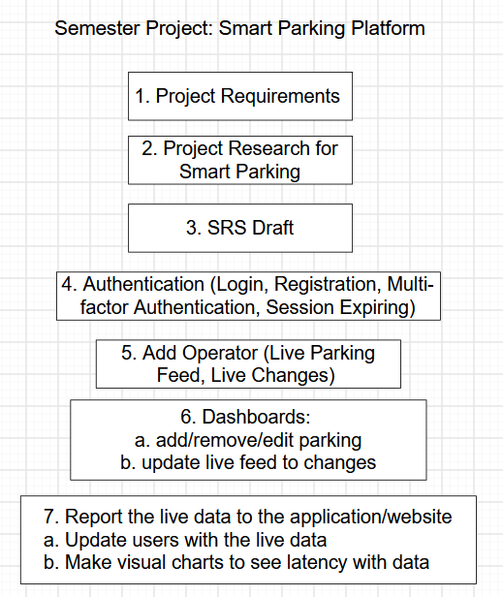
Gantt Chart
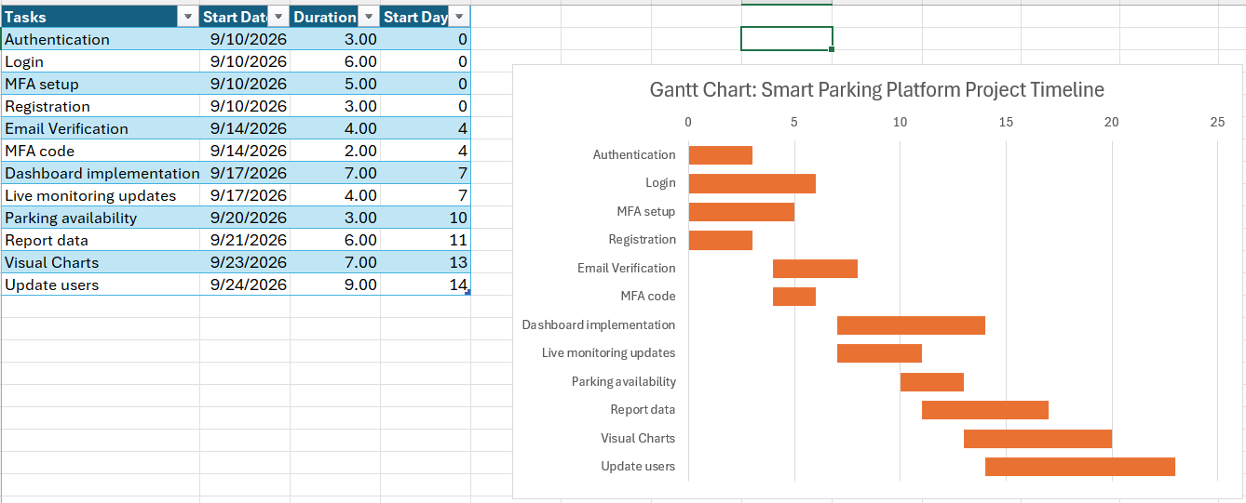

Trello Board for Backlog and Sprint Plan 1 Screenshots
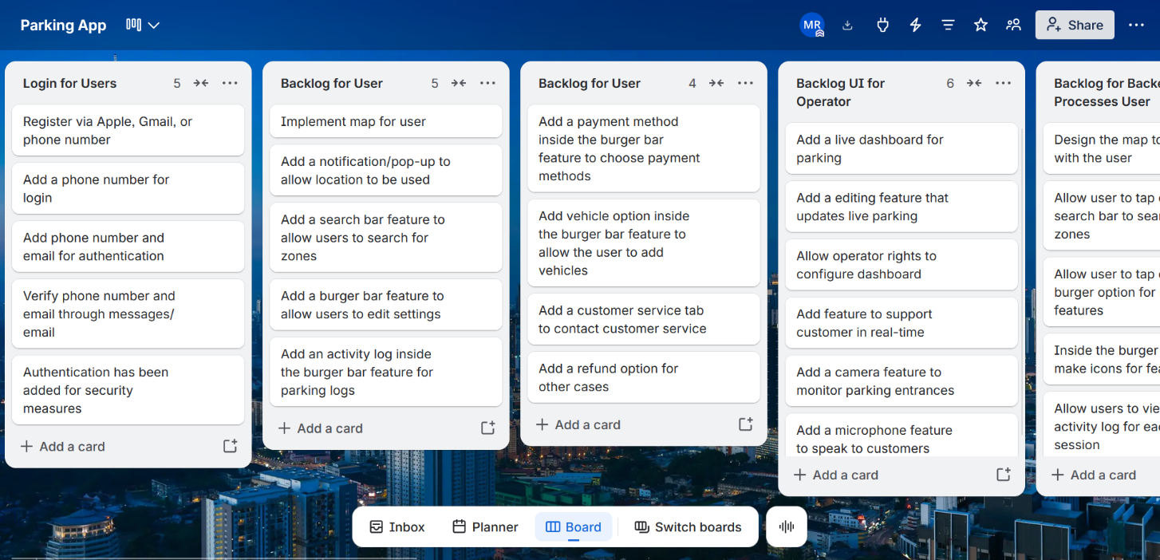
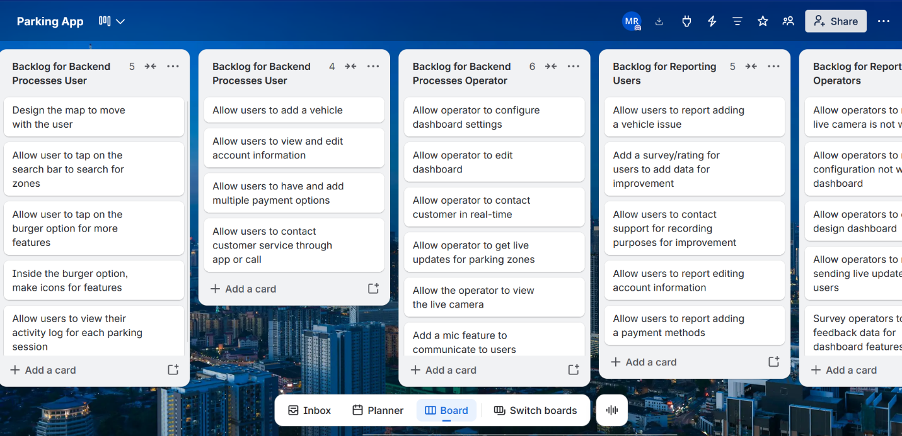

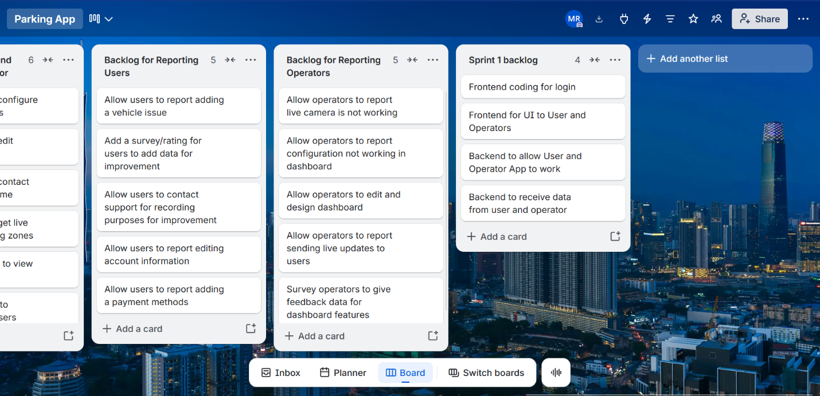
Table for identifying and listing at least 4 risks each category: Technical, Schedule, People, Financial
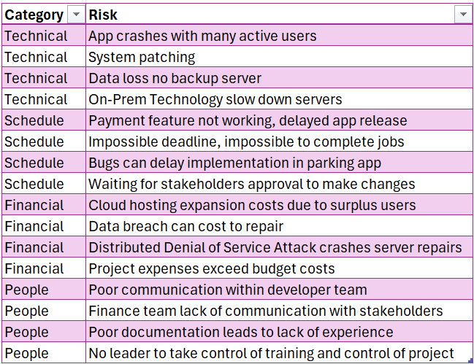
Risk Register
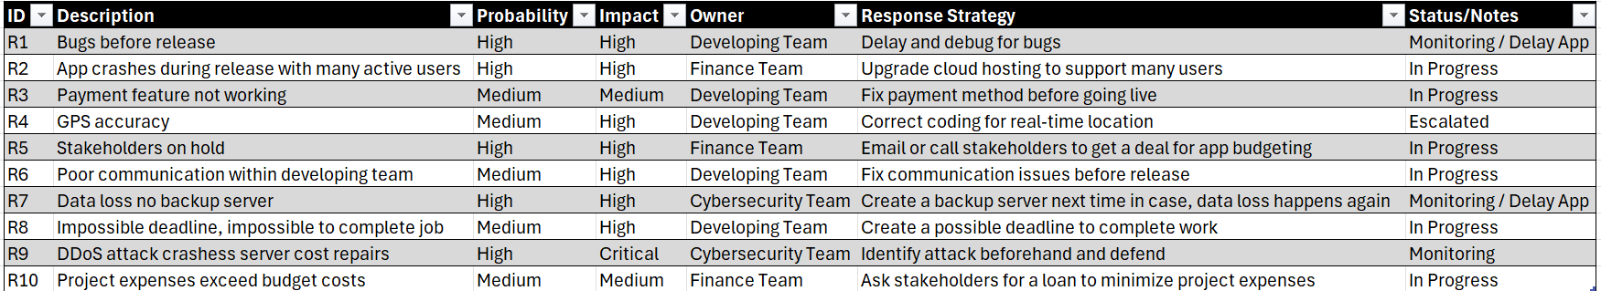
Communication Plan
Team | Meeting | Cadence | Reporting Method
Development Team | Daily Scrum | Daily | Scrum Leader
Cybersecurity Team | Bug and vulnerability meeting | Bi-weekly | Senior Cybersecurity Analyst or Engineer
Finance Team | Budget + Weekly Costs Meeting | Weekly | President of the Finance
Technician Team | Repair & Maintenance Meeting | Weekly | Repair + Maintenance Senior
UX Design Team |  | Weekly | UX Design Manager
Stakeholders/Investors |  | Monthly | Project manager
Project Manager | Leader of meetings | Weekly | Project manager
City | City partnership meeting | Semi-Monthly | Partnership
All teams | Sprint Review + Project Overview: Month 1 | Monthly | Recorded meeting through Teams or Zoom

Roles and Resources
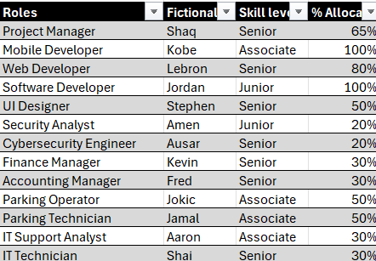
Cost Plan
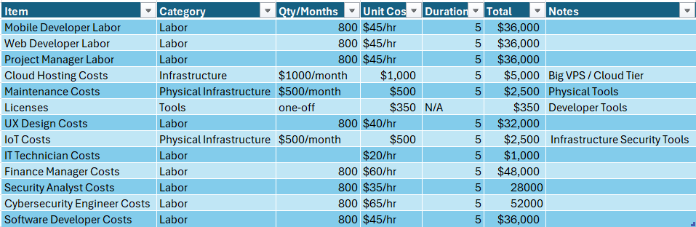
Resource Plan
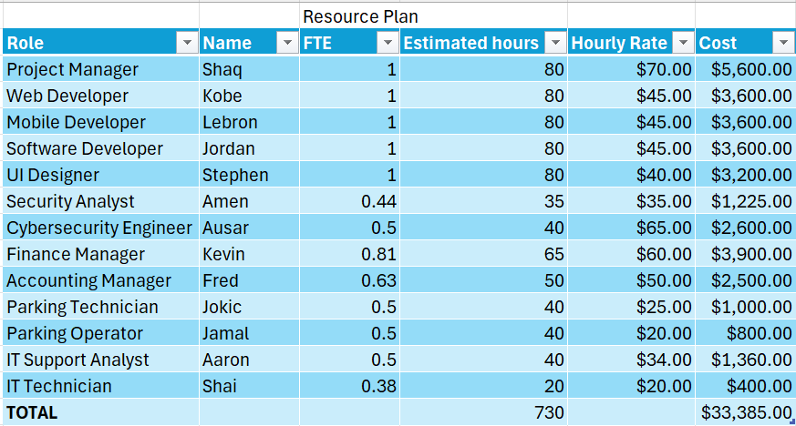
RACI matrix
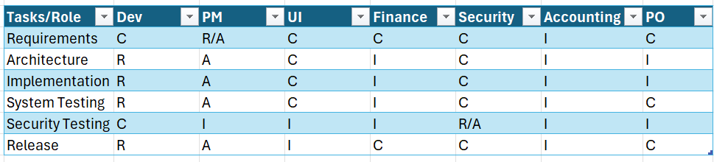

Power Interest Grid
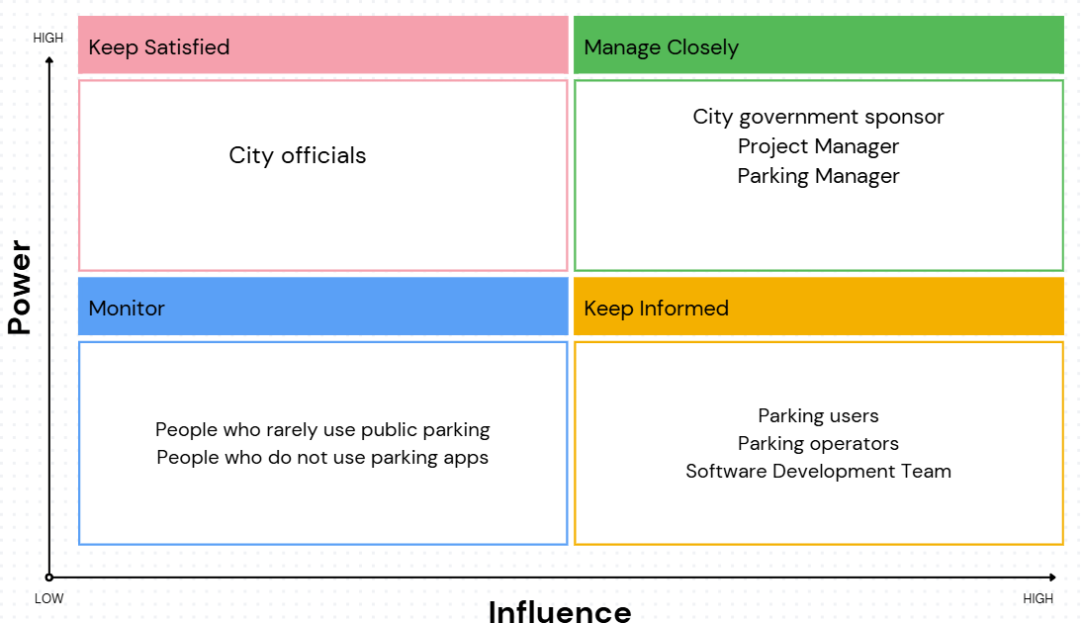

Team Charter
Mission | Scope | Goals
To provide a smart parking platform for users to navigate parking easier | To develop a smart parking platform app for users and provide the best user experience | This smart parking platform will be different from other apps providing more features and accessibility for users
Strengths & Skills | Roles & Responsibilities | Metrics for Success
Great collaborative team that is willing to take insight into different perspectives of all teams. Good soft skills and technical skills. | Who:  Development team takes care of the app from the frontend to backend.  Finance team: Handles the budget and financing of software  Cybersecurity team: Takes care of unusual activities for the app  UI Team: Helps with the user experience and design of the app  Project Manager: Handles all the meetings and controls the project objectives  Technician team: Fixes the parking gates and handles the parking dashboard | Measure success through customer satisfaction being able to be responsive, caring, and informative about changes happening within the app.
Values | Norms | Communication Plan
All teams conduct business in a professional manner with clear communication. Always treat others with respect and keep a positive attitude. | Weekly updates, expectation to perform at work, and resolving conflict as a team | The teams will stay connected through Teams call or messages. They will share most of their data through OneDrive.

Project Charter
